PE Funding

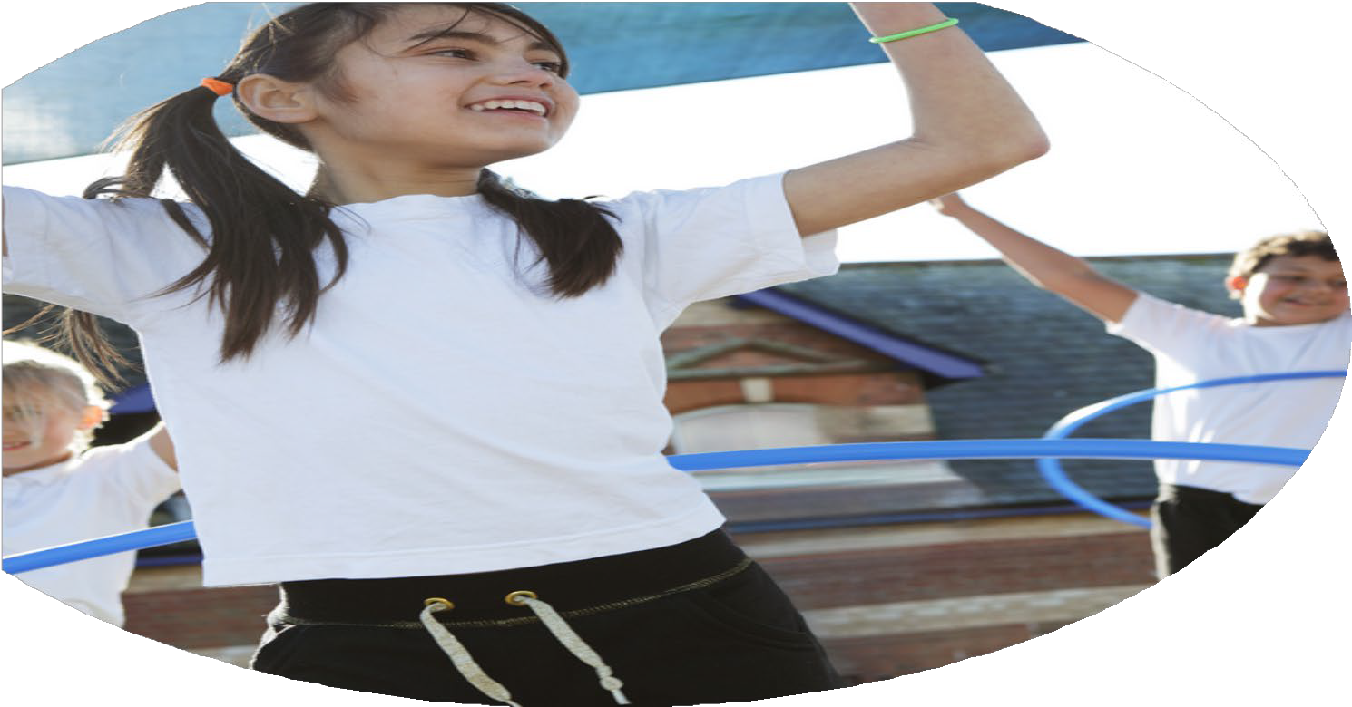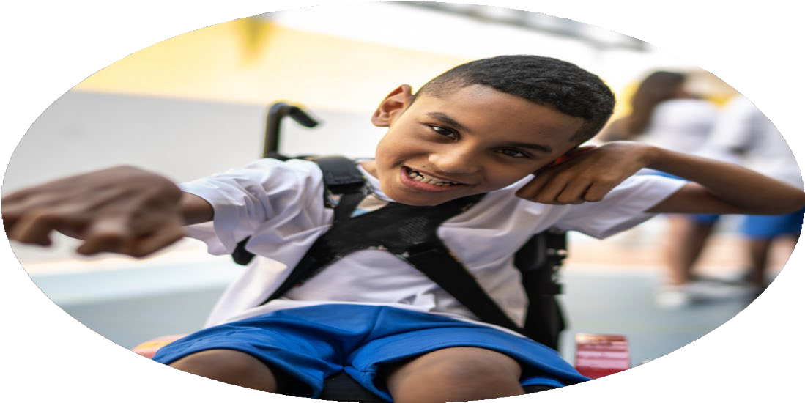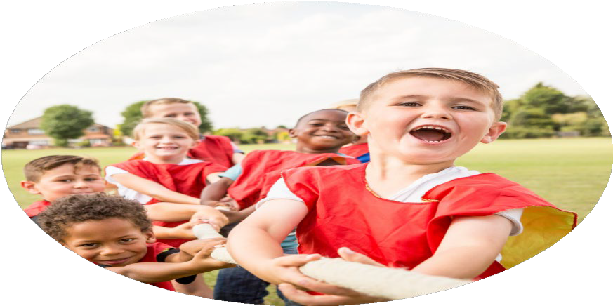

Evaluation Form

**Commissioned by**

**Created by**

Images courtesy of Youth Sport Trust

**PE Funding Evaluation Form**

 It is intended that this template should be used as preparation for the completion of the statutory digital reporting tool being introduced this academic year. You can upload data (including swimming) from this template onto this platform once it becomes accessible.

 Before you decide how you are going to use the funding for this academic year you should reflect and evaluate the impact of your use of the funding in 2024/25.

 All spending of the funding must conform with the terms outlined in the Conditions of Grant document.  The template is a working document that you can amend/update during the year.

 Based on your evaluation of last year’s funding you should decide what you intend to do this academic year, how you will do it, and what impact you expect it to have.

It is important that the funding is used effectively and based on your school’s needs.

 You must use the funding to make additional and sustainable improvements to the PE and sport in your school.  You must develop and add to the PESSPA activities that your school already offers.

*Summative digital reporting from June 2025 will continue to include swimming and water safety information therefore funding can be used to provide top-up lessons where necessary to ensure pupils meet national curriculum swimming requiremen*

***See Impact statement 2023-2024***

|  |  |
| --- | --- |
| What are your plans for 2024/25? | How are you going to action and achieve these plans? |
| Intent | Implementation |
| * To continue to offer all children in school the opportunity to access swimming, by funding the swimming pool and coaches to come in for a 6-week block * Work towards the School Games Mark- Preferably GOLD * Children to take part in a range of external school competitions- Funding the South Ribble Partnership * Continue to fund the Lancashire PE Passport scheme of work so teachers are able to deliver enjoyable and worthwhile lessons * Funding to be used to upskill staff on the use of the PE passport school * Equipment audit and new resources purchased * Extra-curricular opportunities for all children after and during school including active playtimes/lunchtime clubs | * Good communication with SLT and staff on spending, e.g. budget meetings and staff meetings to be delivered by Subject Lead- BS      * Staff and child questionnaires to be completed at different points in the year to ensure consistency * Monitor the use of PE passport and assessment tools to ensure that it is being used effectively by staff including lesson observations and drop ins. * Liaise with South Ribble to ensure smooth running of extra-curricular activities and competitions. * Staff willing to run lunch time and after school clubs to promote active playtimes and extra-curricular opportunities |

|  |  |
| --- | --- |
| What impact/intended impact/sustainability are you  expecting? | How will you know? What **evidence** do you have or  expect to have? |
| The sports funding in our school is expected to have a significant positive impact on students’ physical health and wellbeing by encouraging increased participation in physical activities, which helps develop lifelong healthy habits. It will enable us to improve the quality of physical education through better equipment, facilities, and coaching, ensuring students receive high-quality instruction. This funding will also promote inclusivity by engaging a wider range of students in sports, which supports their academic performance, social skills, and teamwork abilities. Additionally, it fosters stronger community connections by bringing families and local groups together around school sports events. Importantly, the funding supports the sustainable development of sports programs by creating pathways for talent identification and ensuring the school can maintain and grow these opportunities long-term. | We will know the impact of the sports funding through a combination of quantitative and qualitative evidence. This includes tracking increased student participation rates in sports and physical education classes, monitoring improvements in students’ physical fitness levels, and observing higher attendance and engagement in sports-related activities. We also expect to gather feedback from students, parents, and staff through surveys and focus groups to assess changes in wellbeing, confidence, and teamwork skills. Additionally, records of sports event participation, achievements, and progression pathways for talented students will provide measurable outcomes. Together, this evidence will demonstrate both the immediate benefits and the sustainability of the sports programs supported by the funding. |

|  |  |
| --- | --- |
| What **impact/sustainability** have you seen? | What **evidence** do you have? |
| So far, we’ve seen a really positive impact from the sports funding. More students are getting involved in physical activities, including some who wouldn’t usually take part. There’s been a noticeable boost in confidence, teamwork, and general enthusiasm for sports around the school. One of the biggest benefits has come from funding a temporary pool onsite. This has made swimming much more accessible, especially for children who might not have had the chance to attend regular lessons outside of school. As a result, we’ve seen a big improvement in water confidence and swimming ability across different year groups. The pool has also helped meet national curriculum requirements for swimming, which can be difficult for some schools to achieve. Alongside this, the funding has allowed us to improve equipment and facilities more widely, helping us build a sustainable PE program. Teachers are more confident delivering lessons, and we’re starting to build stronger links with local sports clubs to give children even more opportunities beyond school. | * Assessment Data * Subject Leader monitoring * Lesson evidence on PE passport app * Pupil questionnaire * Parent questionnaire * More children signing up for clubs and extracurricular activities * Children taking part in a range of physical activity outside of school * School Games Mark Award- Gold |