 | Autumn 1 |  | Autumn 2 |  | Spring 1 |  | Spring 2 |  | Summer 1 |  | Summer 2
Nursery/Rec | Access to Mini-mash and Purplemash in continuous provision throughout the year.
Key to specific area of Comuting | 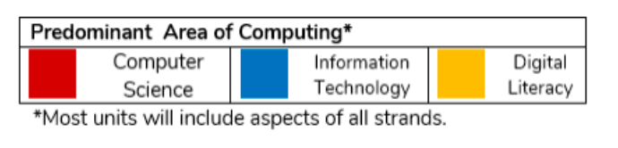
Year 1 | Online safety/ Exploring PurpleMash | Grouping and Sorting | Pictograms | Online Safety | Lego Builder  Maze Explorers |  | Digital Literacy - Animated Story Books |  | Coding |  | Spreadsheets
 |  |  |  |  |  |  |  |  |  |  | Using Technology Outside of school
Year 2 | Coding |  | Spreadsheets | Online Safety | Questioning |  | Creating Pictures |  | Making Music | Effective Searching | Presenting Ideas
Year 3 | Coding |  | Branching Databases | Online Safety | Touch Typing and Spreadsheets |  | Email (Including Email safety) |  | Simulations | Graphing | Presenting Ideas
Year 4 | Coding |  | Spreadsheets |  | Logo | Online Safety | Writing for different Audiences |  | Effective Searching | Animation | Making Music | Hardware Investigators
Year 5 | Coding |  | Spreadsheets |  | Databases | Online Safety | Game Creator |  | 3D Modelling | Concept Maps | Word processing
Year 6 | Coding |  | Spreadsheets | Online Safety | Blogging | Networks | Text Adventures | Binary | Quizzing |  | Spreadsheets  Excel

